**INTEREST RATE VOLATILITY, THE YIELD CURVE AND BOND PRICING**

**Problem Statement:** Start by looking at the Government of Canada bonds, specifically, their yield to maturity (YTM) metric. First, graph YTM curve. Observe shape of the yield curve; see how it changes through time. Pay attention to 3 different type of curve movements – level (e.g. 10-year note YTM changes), slope (e.g. spread between 10Y and 2Y bonds, curvature (e.g. butterfly made up of 2y, 10y and 30y bonds) Once you get that base intuition, try to apply PCA. See if you can normalize PCA components into level effect, slope and curve. Once it is done, progress to ML framework. Inputs should be YTMs again.

**Introduction**

**The Workflow of the entire process is :**

Population(Universe of possible yield curves)

The dataset on which time-series Analysis is performed.(2,5,10)

Applying Curve Decomposition Algorithm (PCA)

Applying neural network model on the PCA factors to get the residual plots.(Machine Learning)

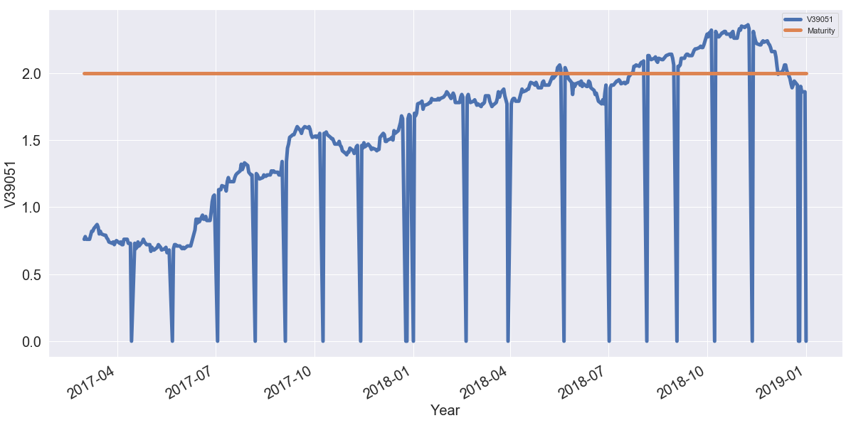

The above figure shows Time Series Analysis of 2 year yield to maturity metrics of the Canadian Government Bonds which are non-Stationary in nature. This is an upward sloping curve which is monotonic in nature signifying that bonds that have longer terms have large returns.

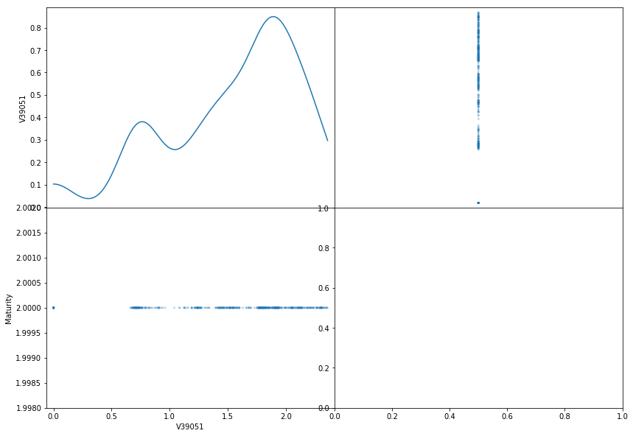

The above figure shows singular matrix decomposition using principle component analysis.

Results of Dickey-Fuller Test:

Test Statistic -1.162539

p-value 0.689500

#Lags Used 10.000000

Number of Observations Used 469.000000

Critical Value (5%) -2.867722

Critical Value (1%) -3.444370

Critical Value (10%) -2.570063

As the value of p>0.05 so series is non stationary in nature.

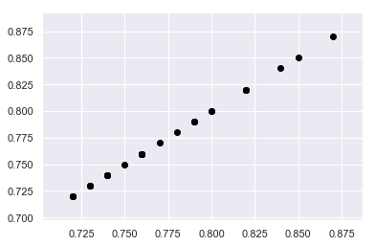

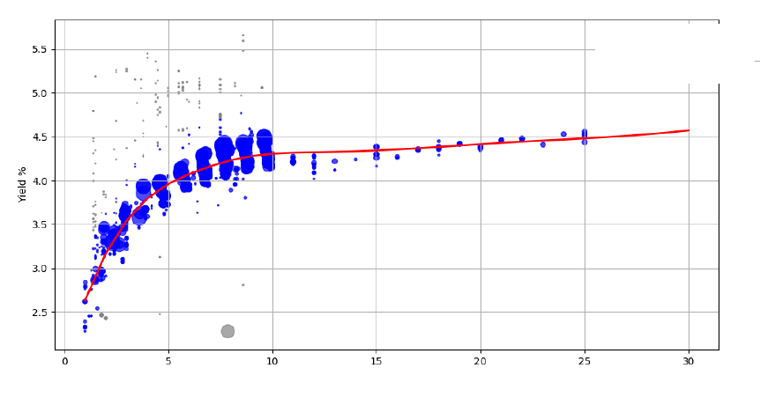

The above figure depicts the slope of the yield curve. The points on the yield curves depict the fitted points on the line. The blue circles represent the trades weighted by their attributes such as the yield of the trade and the date the trade occurred. Larger circles denote points with sample weights that are relatively higher. Intuitively, the data points corresponding to small circles do not influence the yield computation as much as the data points with large circle.

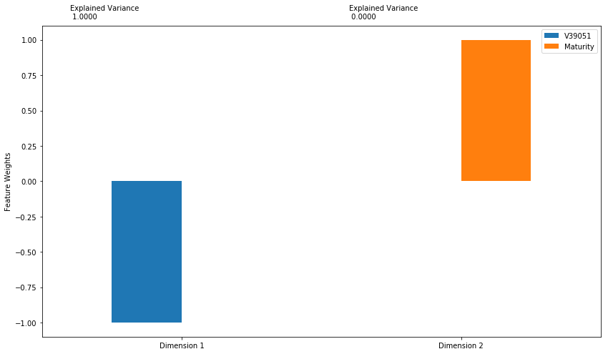

The above figure shows the relative sizes of the eigen values from a PCA for sample yield curve changes for the Canada at monthly intervals, where the sample maturities were ( 2, 5, 10years).

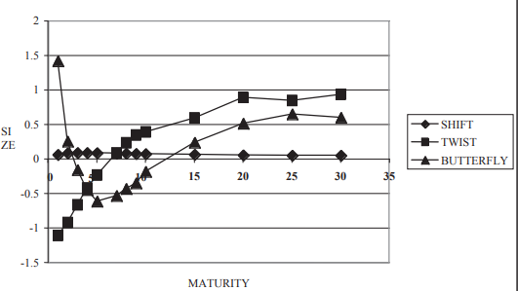

The above figure show that the first eigen function is close to a flat line, that the second rises monotonically (but is seldom a straight line), and that the third imposes some curvature motion. These functions are usually interpreted as shift, twist, and curvature.

The above figure shows the nelson siegel model using curve decomposition algorithm. The above figure shows the calculation of shift, twist, and curvature.

|  |  |  |  |  |  |
| --- | --- | --- | --- | --- | --- |
| Yield | T | Nss |  | ß1 | 0.01 |
| 0.30% | 2 | 2.60% |  | ß2 | 0.01 |
| 1.94% | 4 | 2.50% |  | ß3 | 0.01 |
| 2% | 5 | 3% |  | λ1 | 1 |
| 1.66% | 10 | 4% |  | λ2 | 1 |

**Price a Stepped Coupon Bond**

Price single stepped coupon bonds using market data.

Define data for the interest-rate term structure.

Rates = [1.98;2.02;1.99;1.97];

ValuationDate = 'Jan-1-2018';

StartDates = ValuationDate;

EndDates = {'Jan-1-2019'; 'Jan-2-2019'; 'Jan-3-2019'; 'Jan-4-2019'};

Compounding = 1;

Create the stepped bond instrument.

Settle = '03-Jan-2018';

Maturity = {'01-Jan-2019';'02-Jan-2019';'03-Jan-2019';'04-Jan-2019'};

CouponRate = {{'06-Jan-2019' .0425;'07-Jan-2019' .0750}};

Period = 1;

Compute the price of the stepped coupon bonds.

PZero= bondbyzero(RS, CouponRate, Settle, Maturity ,Period)

PZero = 4×1

35.1682  
 34.6095  
 34.8656  
 34.9970

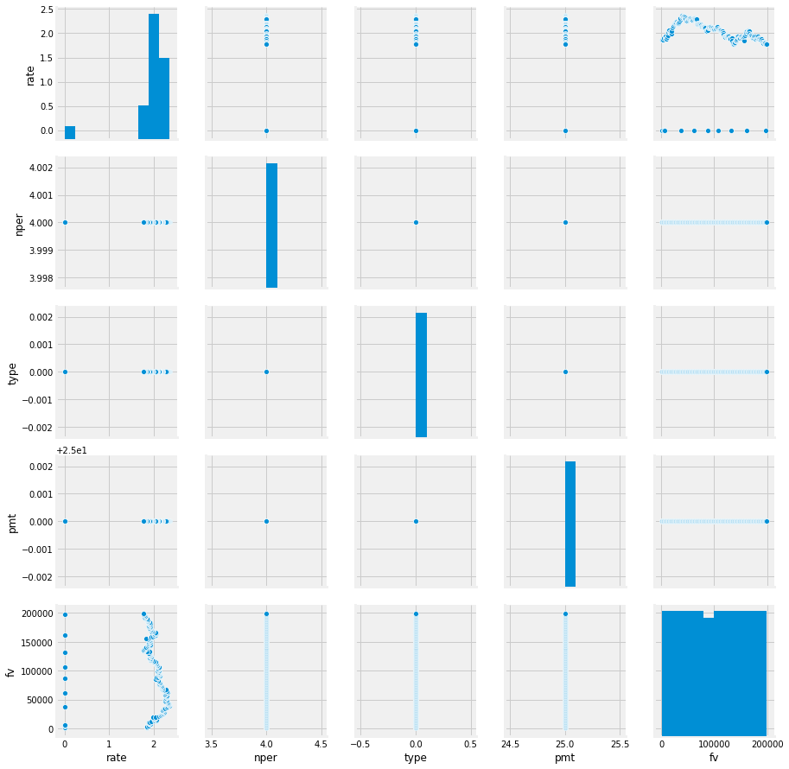

This section examines the average values and variances of level for different yield curve measures. It shows level of the factors affecting the present value of bond. It shows behavior of daily changes in these levels how it affects the daily yield curve. The historical shapes of the distributions have interesting repercussions for the given dataset. These models have small change in yields and showing different volatility levels.

|  | **V39051** | **Maturity** |
| --- | --- | --- |
| **count** | 480.000000 | 480.0 |
| **mean** | 1.535625 | 2.0 |
| **std** | 0.585718 | 0.0 |
| **min** | 0.000000 | 2.0 |
| **25%** | 1.220000 | 2.0 |
| **50%** | 1.765000 | 2.0 |
| **75%** | 1.940000 | 2.0 |
| **max** | 2.360000 | 2.0 |

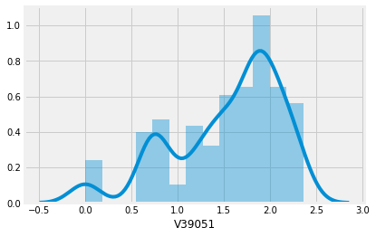

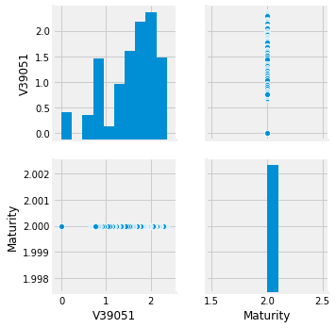

This result is therefore consistent with our view that different maturities are subject to different parameters, and that the presence of opposite signs of twist between these portions of the curve does not correspond to a genuine curvature movement. If, on the other hand, this behavior were seen at maturities of (say) 10 years, which is a long way from a parameter change point and in the middle of the “bond” portion of the curve, then we would say that there is genuine curvature occurring, and the algorithm will pick this up.

'RMSE value for k= ', 1, 'is:', 0.023964673074247354)

('RMSE value for k= ', 2, 'is:', 0.02383391607679183)

('RMSE value for k= ', 3, 'is:', 0.0237447200108795)

('RMSE value for k= ', 4, 'is:', 0.02419000310045455)

('RMSE value for k= ', 5, 'is:', 0.024727964376839065)

('RMSE value for k= ', 6, 'is:', 0.02552043178066554)

('RMSE value for k= ', 7, 'is:', 0.024875825400223466)

('RMSE value for k= ', 8, 'is:', 0.024412364524287005)

('RMSE value for k= ', 9, 'is:', 0.023842008263246013)

('RMSE value for k= ', 10, 'is:', 0.024046973706569538)

('RMSE value for k= ', 11, 'is:', 0.023941671353121946)

('RMSE value for k= ', 12, 'is:', 0.023901199993119838)

('RMSE value for k= ', 13, 'is:', 0.024102137884938552)

('RMSE value for k= ', 14, 'is:', 0.024346620638354254)

('RMSE value for k= ', 15, 'is:', 0.024476935477513787)

('RMSE value for k= ', 16, 'is:', 0.030597972058573116)

('RMSE value for k= ', 17, 'is:', 0.042158914678744476)

('RMSE value for k= ', 18, 'is:', 0.05422219376137687)

('RMSE value for k= ', 19, 'is:', 0.06561997170347635)

('RMSE value for k= ', 20, 'is:', 0.07627963904826328)

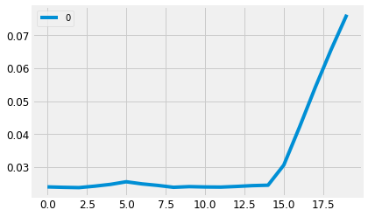

The conclusion is that, similar to the other major bond markets, variations in the Government of Canada yield curve over the sample period could be almost totally explained by three factors level, slope, and curvature. While the total proportion of variance explained remained very stable over the entire period (ranging from 99.0 per cent to 99.9 per cent), the breakdown of the three factors varied considerably (level, slope and curvature).

APPLYING NEURAL NETWORK THEORY

